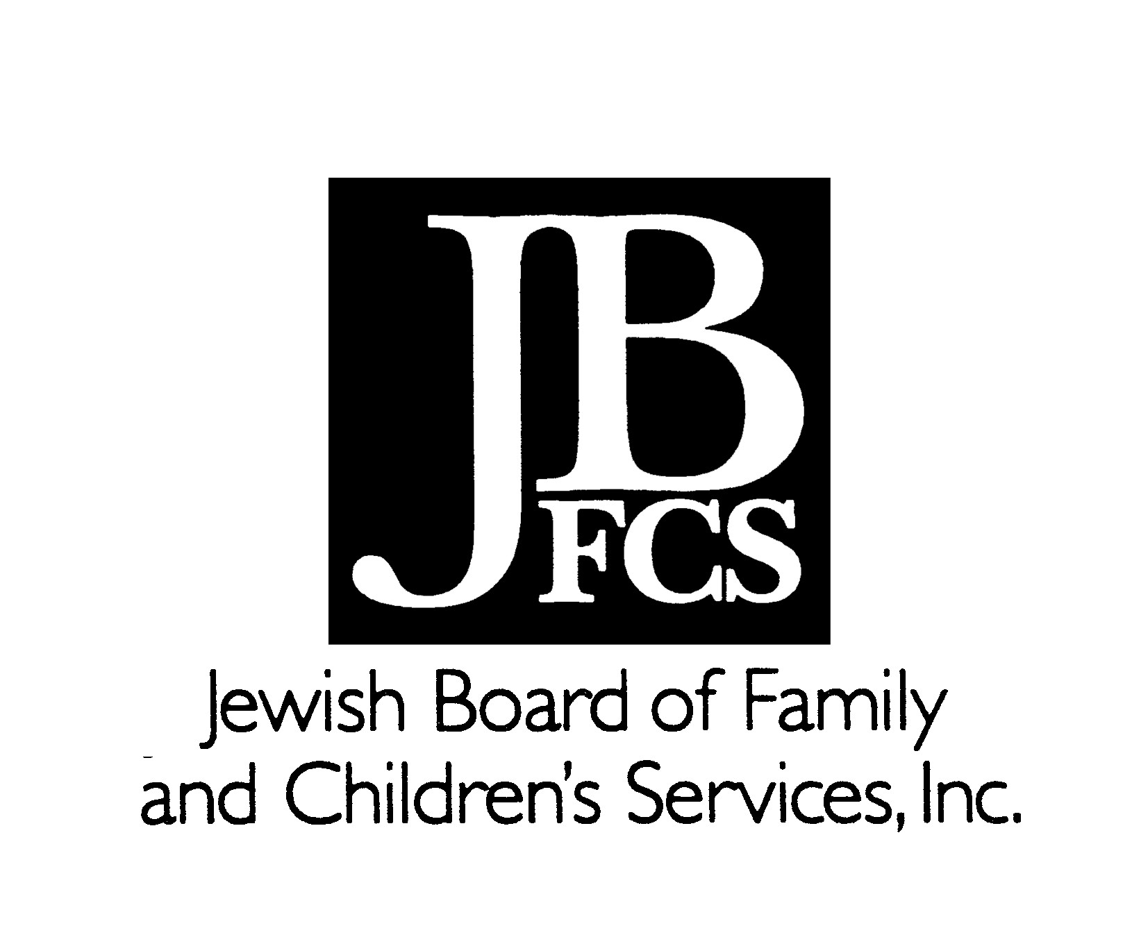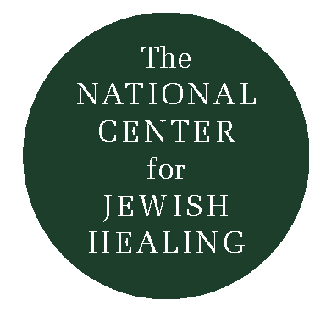
Jewish Community Assessment
Who, What, How and Where
&

Potential Partners, Programs and Human Resources

In order to assess how to integrate Jewish spiritual resources into services you must assess your community:
- How many Jews are there
- How many affiliated, unaffiliated and interfaith families
- Their ages
- Are there many extended families in the community; grandparents, their children and grandchildren?
- Are adults responsible for their children and for their parents?
- Mobility – in and out of the community
- Isolated homebound
- Where do people go in times of trouble, i.e.
( examples: Gilda's Club; Wellness Centers; Yoga; hospitals other social service and healing resources?)

Assessing your agency and/or assess which agency you might partner with
- Who is the agency serving?
- What is the agency’s mandate?
- Is it a Jewish or a multicultural agency?
- What does the Board look like?
- How do they view the agency’s mandate?

Examine the community's key institutions
* Synagogues
- What are the needs?
- What are their resources (healing services, spiritual counseling, groups)?
- Are their shifting demographics?
- What are patterns of utilization for the “affiliated”
- Do they have volunteer programs? Do they visit the ill?
- Are they addressing the bereaved?

* Examine other major Jewish institutions in the same way:
JCC, JFS, Jewish Nursing Homes, Hospice, Senior Service Providers etc.

* Are Jews in non-Jewish institutions?
Who do they serve?
How do they serve them?
What are the unmet spiritual needs?
Is anyone doing anything to educate/sensitize staff to Jewish spiritual care?

* What agencies are doing Jewish education in the community?
* Are they addressing issues such as: what Judaism says about grief, illness, suffering, spiritual journeying etc.? What kind of interdisciplinary resources are there in the community?

* What is there most interest in?

* Where are the gaps?

Program Planning: Building Partnerships, Services and Human Resources

Institutions:

Federations

JFSs
JCCs
Healing Centers
Chaplaincy Programs
Synagogues
Senior Service Providers
Board of Rabbis
Hospitals
Physicians
Hospice Providers
Schools
Seminaries
Libraries
Non-sectarian organizations serving people with special needs
Wellness Programs
Community at large

Human Resources

Rabbis
Cantors
Volunteers/ Lay leaders ( including Youth and families)
Artists – Writers/Singers/Storytellers/Dancers
Jewish Educators
Chaplains
Social Workers
Nurses
Medical Professionals
Spiritual Counselors
Mental Health Professionals

Services

Community Education

Workshops

Healing Services/Circles

Spiritual Support Groups
Caregivers
Bereavement
Illness
Infertility
Estranged Children
Women’s/ Men’s Groups
Wellness Programs (Yoga, Meditation, Writing)
JACS
Bikur Cholim (Visiting the Sick)
Discussion Groups
Older Adult Programming
Holiday Programming
Special Camps
Staff Training
Art Programs
Library/Resource Center
Rosh Chodesh Groups
Training Programs for Professionals
Spiritual Retreat Programs
Doula/ End of Life Visiting
Spiritual Counseling

