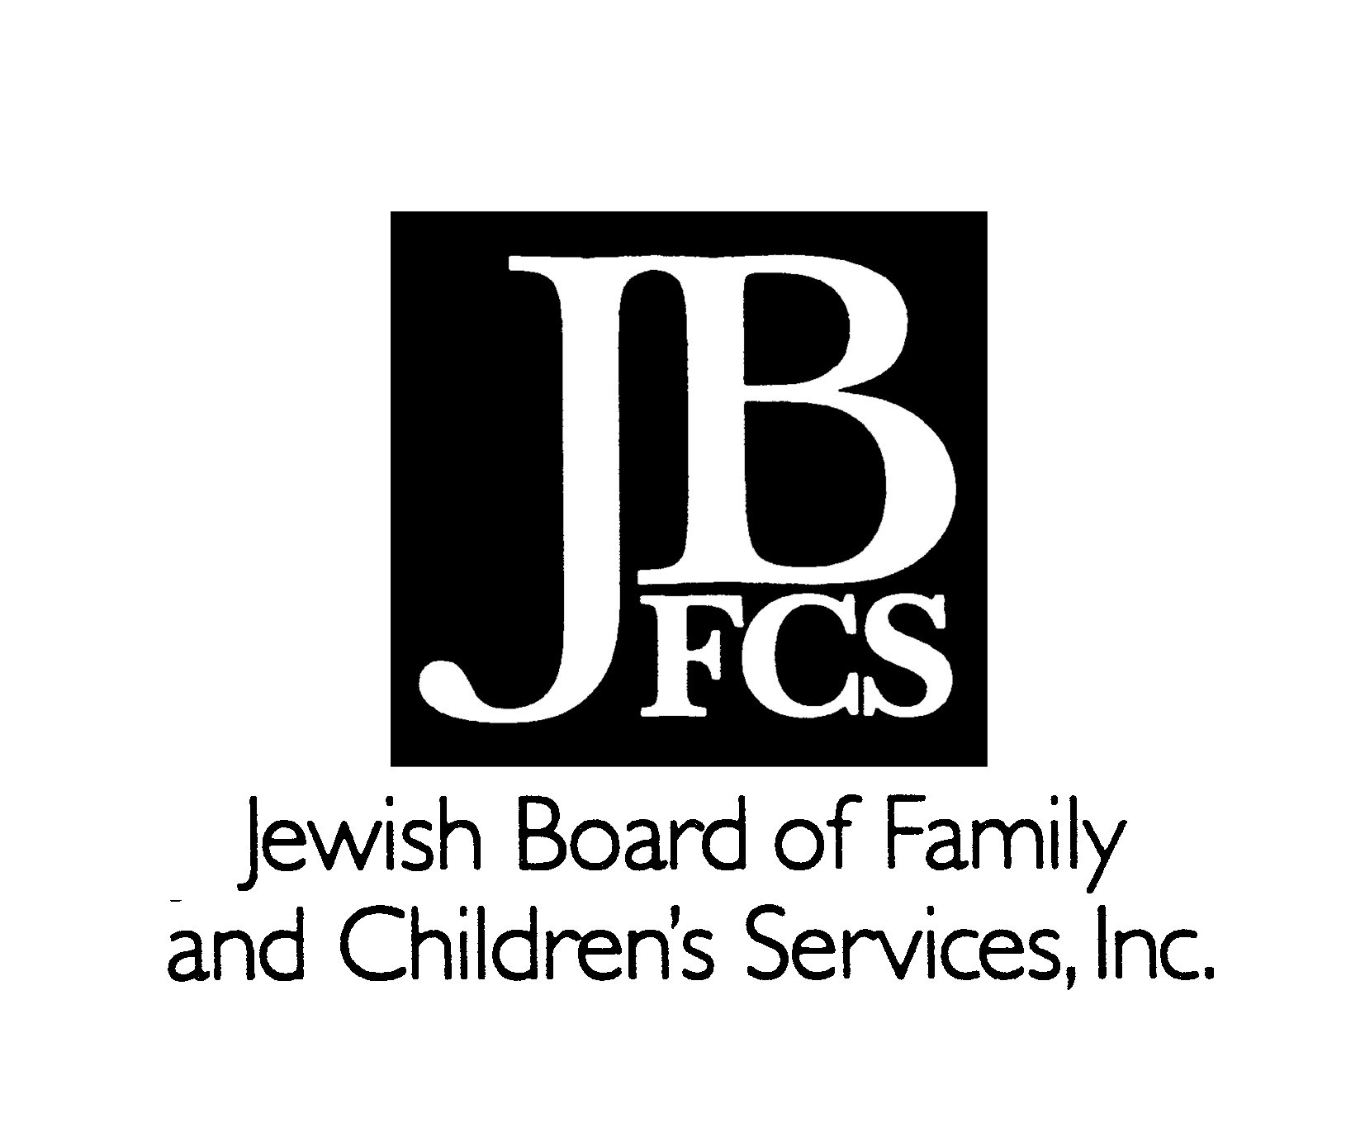
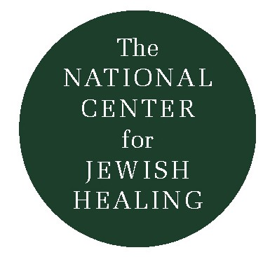
Is Jewish Healing Kosher?

By Rabbi Joseph S.Ozarowski, author of To Walk in God’s Ways: Jewish Pastoral Perspectives on Illness and Bereavement (Jason Aronson, 1995). Prepared for the Outstretched Arm, Volume 1, Issue 1, 1998.

The Jewish healing movement, if we can speak of such a thing, is a relatively new phenomenon in our community. It has received considerable publicity in both the Jewish and secular media, and has had a profound impact on the lives of many. Yet it has led me and perhaps other traditional Jews to ask some important questions. For instance, is the movement grounded in Jewish theology from a traditional point of view? Can people who are personally observant on practice, and/ or people who identify as denominationally Orthodox, feel comfortable with and even actively support the Jewish healing movement? And specifically, are there conflicts with Halakha or Halakhic observance with regard to any of the particular programs or modalities being used and developed, such as services of healing?

I have explored some of these issues and would like to share some of my findings and thoughts. In 1979 I was privileged to hear an oral lecture given by Rabbi Dr. Joseph B Soloveitchik, of blessed memory, which subsequently included in his book Shiurim L’Zekher Avi Mori, in the charter entitled “Liz’ok Ul’haria Al Kol Tzara Shetavo”. In his lecture, the Rav suggested that there are two forms of prayer. The most well known form is t’filoh, which he understood to mean the structured prayer of our liturgy andsiddur.But
the second parallel type is a more unstructured prayer which he termed z’aka, on Numbers 10:9-10, Talmud Bavli Taanit 18, and the Maimonides code (laws of fasting 1:1):sources which teach us the mitsva to blow the hatzotzorot, the trumpets, in times of trouble.

I would humbly suggest that the work of the Jewish healing movement falls
into the category of z’aka. Everything we do, from healing services, the use of
psalms, the assistance we give to caregivers, the training we offer clergy and others
help people fulfill this unstructured mitva of crying out to Hashem in times of pain and trouble. We do this because the Torah guides us in this manner and because it helps.

The rabbis of old intuitively knew this. Their understanding is reflected in
Torah sources and wisdom which guide us in seeing how visits and prayer can
make a difference in the life of someone living with illness. Some wonderful
examples from the Talmud in Nedarim are:

R. Abba said in the name of R. Hanina: One who visits a patient takes
away a sixtieth of his pain.

When R. Dimi came he said, “Whoever visits the sick causes him to
live, and whoever does not visit the sick causes him to die.” How does
one cause’ this? Does this mean whoever visits the sick will ask
mercy (pray) that he may live, and whoever does not visit the sick will
ask mercy that he should die? Would you think this? But (it must mean)
that whoever does not visit the sick will not ask mercy, neither that he
should live or die.

Rabin said in the name of Rav: From where do we know that the Holy
One, Blessed Be He sustains the sick? As it says, “The Lord will
support him upon his bed of illness.” (Psalm 41) Rabin also said in the
name of Rav: From where do we know that the Divine Presence rests
above the invalid’s bed? From the verse, “The Lord will support him
upon his bed of illness.”

Recent clinical evidence shows that the rabbis were right. Dr. Herbert Benson, in his book Timeless Healing, and Dr. Larry Dossey in Healing Words, have gathered studies showing the benefits of prayer, visits, religious faith and church or synagogue affiliation on those who are ill. Their statistics show that those whose lives include these elements on the whole live longer after critical and chronic illness. In psycho-social terms, it seems clear that religion eases the spirit, relaxes the body, and offers a support system. And of course, anything that can assist people in life and health is certainly acceptable according to Jewish law. But I wonder if we have been ignoring the most important aspect from a religious point of view: that the Rofeh Kol Basar, the One who heals all flesh, is listening to our z’aka prayers?

The use of “healing services” as a means of bringing elements of our liturgy to those in need has become increasingly popular across the country. I have discussed healing services in general, as well as their possibility within Orthodox settings, with Rav Gedaliah Schwartz, Rosh Bet Din of the Rabbinical Council of America (largest mainstream Orthodox Rabbinic group in the world). He is generally favorable to any efforts that assist people in need regarding mental health, and endorses the idea of creative services as long as they are obviously different from traditional davening. In this way, halakhic issues such as seating by gender, counting women for a minyan or using certain prayers requiring these standards do not become obstacles. Since calling such a gathering a “service” may be misleading to some who would confuse it with traditional davening, he suggests finding alternative nomenclature, such as healing “circle” or other such title.

Regarding many of the brakhot used in these settings, he suggests that people who have not said birchot hashahar and elokai neshama in the morning may say them all day, since they are not tied to a time frame (even though most people perceive them as “morning brakhot.”) He did have a halakhic objection to the use of the prayer asher yatzar, whose halakhic context is as a “bathroom” blessing. He felt that it can only be recited after the use of the toilet (for which it thanks God) or as part of the morning blessings, which are in effect the same thing. He pointed out, however, that there would be no problem in studying or reflecting upon this brakha, and suggest that footnotes in service booklets might be included to reflect these considerations.

In conclusion, I believe that z’aka, the unstructured crying out to God in times of trouble is the central theme of the Jewish healing movement. It can be seen as fully sanctioned by our tradition and has been clinically shown to truly help those in need. With sensitivity to Halakhic issues, our work can be shared with an ever-widening circle of Jews in need of the Torah’s healing power.

