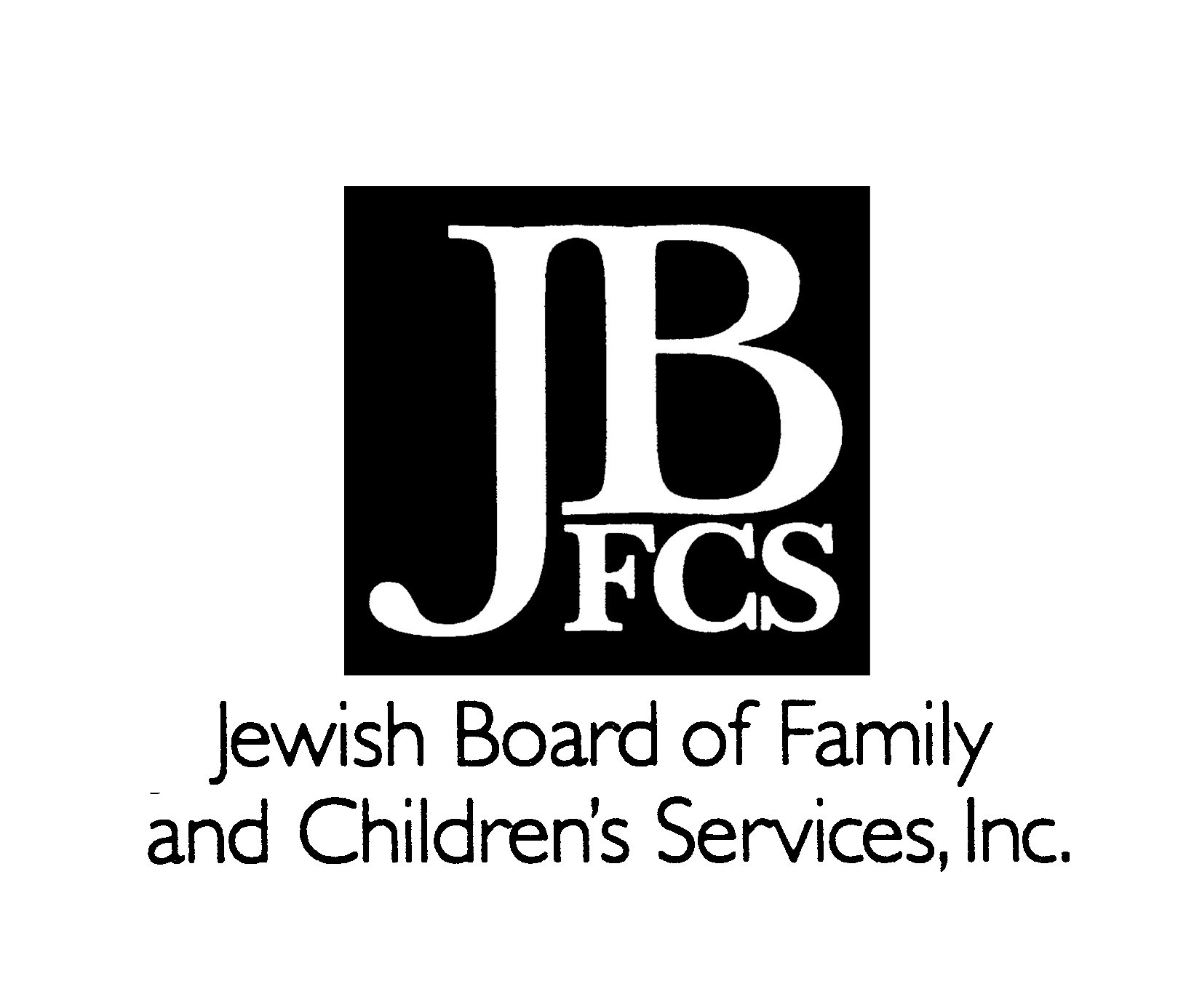
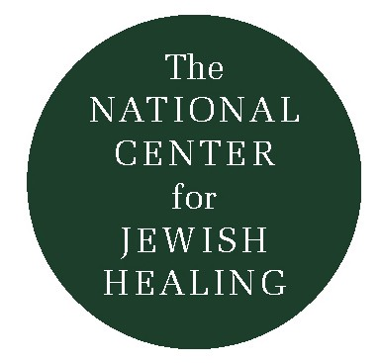
A Slow Dance in Time:
Grief and the Jewish Holiday Cycle

Rabbi Simkha Y. Weintraub, CSW © 2003

What follows is an attempt to begin to chart the resources and challenges that the annual cycle of Jewish holidays may offer for those who are bereaved. Please note that some of these may well cut across all holidays -- for example, “candles” as a helpful ritual, or “loneliness” as a pitfall – so those important words, common to many holidays, may not be noted below. Also, this chart only includes some illustrative/suggestive words to point to some possibilities; different strokes for different Jewish folks! Finally, it includes only some of the more commonly observed markers in the communal Jewish year, omitting, for example, special Shabbatot, “minor” fast days, the very different Rashei Hodesh (New Moons), etc. Please share your additions with me at sweintraub@jbfcs.org. Thanks!

Holiday Salient themes Some Helpful Particular Pitfalls;
and images Rituals/Words Possible challenges

Rosh HaShannah Review, Return Psalms, Prayers Self-Blaming
Rebirth Difficult/healing Overwhelmedness
Self-examination encounters with Despair, Isolation
Forgiveness family, friends Starting over when
Change Rabbinic Guidance you’re stuck
Life in the Balance Tashlikh
Shofar, Cards

Yom Kippur Reconciliation At-one-ment Depletion, Depression
Life/Death Mercy; Kittel Starkness
Belief you are/can be Massive assembly Denouement
forgiven Fasting; Cleansing Feeling low at a high
White; Clean slate Yizkor; Martyrology point
Needing less Poetry; Book of Jonah Alienated, fraudulent
Holiness Break-Fast Disenfranchised

Sukkot Shelter Sukkah; Temporary “Rejoicing” Fullness/Vulnera- Dwelling; Ushpizin Decay

ability Arba Minim Fragility

Nature’s Maturing Hoshannot Circuits Inaccessibility In/security Hag HeAsif/Harvest

Hospitality Kohelet/Ecclesiastes
Intimacy with God Beat the willows
Exposure/Shelter
Rootlessness/Home
Wandering/Return
Exile/Eternity

Holiday Salient themes Some Helpful Particular Pitfalls;

and images Rituals/Words Possible challenges

Shemini Atzeret Assembly Tefillat Geshem Inability to dance
& Simhat Torah Cycle of Torah/Life Yizkor Conflicting emotions
Torah Celebration Aliyot for Bereaved Isolation
Revelry Dancing in the streets
Completing; Starting over
Hanukkah Lights in Darkness Candlelighting Apartness, Isolation
Survival;Victory Latkes, Sufganiot from Party mode
Autonomy/Identity Singing Clash of Inner/Outer
Rededication Gifts, Games Infantilizing
Values clarification Consumerism,
Victory of the Spirit Materialsim
Miracles… …Reality
Judaism publically

Tu B’Shvat New Year for Trees* ‘Tasting’ Seder Irrelevance, Stretch
Cosmic/Intentional Memorial Tree Distant/Abstract
Rebirthing Planting
Honi/Planting for Israel-focus
the future
Restoration of Rel.
to Nature

Purim Victory Megillah reading Infantilization;
Self-mockery Masquerades Dissonance
Appearance vs. Parodies, Farce Inebriation
Reality Purim Torah Threat, and actual,
Measure for Measure Festive S’udah death/destruction

Chance vs. Destiny Mishloah Manot Lack of boundaries;
Threat & Survival Mattanot laEvyonim nihilism
God’s Hidden Face Feel good, let loose
Living in exile (Adloyada); Noisemaking

Passover Bondage & Liberation Cleansing, Changeover Empty chairs
Spring; Rebirth Seder(ritual, symbols) Family, Family,
Exodus; Redemption Haggadah/Telling our Family!
Hope; Renewal story asking our questions Food-centered
God more powerful Elijah (denial and
than Death Re-experiencing indulgence)
Outstretched Arm emergence Labor-intensive
Humility; Gratitude Matzah vs. Hametz
Searching… Search, nullify, burn
Future Redemption Hospitality; Needy

Holiday Salient themes Some Helpful Particular Pitfalls;

and images Rituals/Words Possible challenges

Yom HaShoah Remembrance Silence Overburdening
Loss & Survival El Maleh Rahamim; unwitting disen-
Kiddush Hashem Kaddish; Psalms franchising of
Righteous Gentiles Names; Accounts immediate and
Jobian grappling personal loss/es
with God

Yom HaZikkaron Remembrance Candles, cemeteries, “Bereavement
of those who Psalms, sp. Yizkor, Overload”
died fighting Kaddish, El Maleh
for Israel Silence
Yom HaAtzmaut National Rebirth Celebrations Dissonance
& Independence Psalms, S’udah Distance
& Redemption Poetry
& Strength
Doing for ourselves
Taking history in hand
“Reaping in joy”

Shavuot Giving of Torah Intimate/intensive May seem ‘weak,’ Harvest; Torahstudy; ‘alien’ to many
First Fruits Tikkun
Revelation Entire Book of Psalms
Covenant Yizkor
Ongoing Sinai Natural decorations
Heavens open Eating dairy foods
To Prayer Book of Ruth

Bein HaMtzarim/
Three weeks & Multiple losses Communal mourning; Devastating
Tish’a B’Av Low points; inter/national ‘shiv’ah’ layers of grief
Accumulated Eikhah/Lamentations ‘Impersonal’
Tragedies Iyyov/Job Summertime
End of Jewish Kinot – liturgical poems ‘clash’
Sovereignty of grief; sit on floor
Exile No greeting, no other
Prayers shut out Torah, no tallit/tefillin
by God (Lam. 3:8) Sweeping house in pm,
Yearning and . anticipating Messiah
mutual grieving also naheim paragraph
of God & Israel Lead-in to comfort


* The Four Jewish New Years are Nisan (the “first month”, in the Spring); Rosh HaShannah; Tu B’Shvat (arbor day; agricultural tithing); and Elul (for tithing animals)

