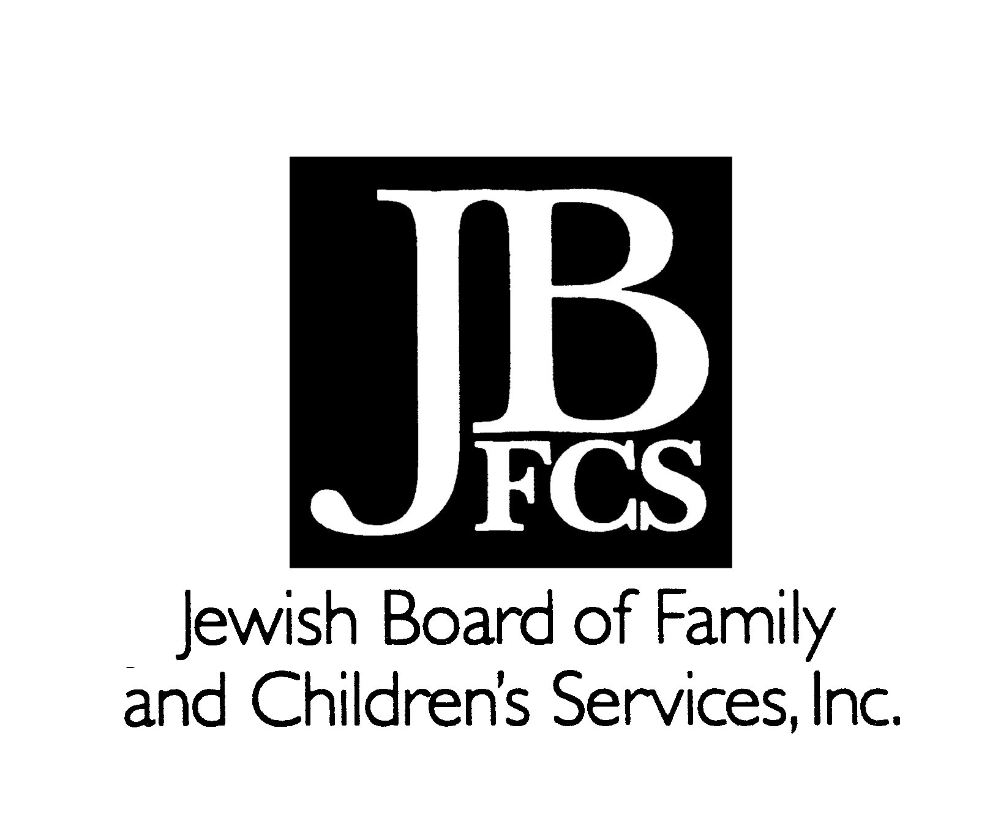
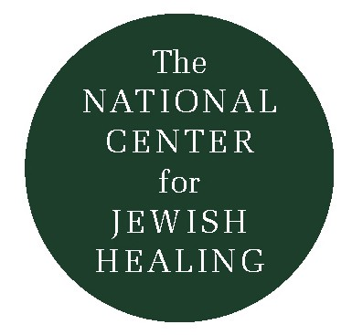
Healing Activities and P’sukim from Tehillim:
Words of Psalms in/as Jewish Meditations for Healing
Rabbi Simkha Y. Weintraub, CSW © 2000

Words of Psalms can be valuable tools in refocusing, centering, and quieting oneself, as a kind of Jewish mantra. Some people post a verse, phrase, or even just a word from a psalm on their office computer screen so they can freely turn to it in the course of a workday; others make their own audio recording of a psalm, or a piece of psalm, in order to play it back while sitting in a quiet, undisturbed setting, or even while jogging, driving, shopping, and so on. More than just another stress-reduction technique, these meditative practices bring the Sacred into the everyday, marrying text with context, bringing Torah into life and life into Torah.

People dealing with illness, suffering, and loss often turn, quite naturally, to the resources of the world around them for spiritual healing – in order to restore a damaged connection to Nature, to reassert that despite everything they are still ba’alei hayyim/active possessors of life, and to renew precious moments of life within Creation. To name, concretize, and sanctify these activities, and to bridge the worlds of the senses with that of the spirit in a conscious manner, Biblical p’sukim/verses may be joined with the actions -- before, during, and/or after the experience.

What follows are 18 “healing activities” that are joined with 18 p’sukim/verses. These verses of Psalms represent possible focal meditations, meant to accompany, not replace, traditional blessings that are connected with many of these activities. For some of these activities, there may be no traditional blessing, and the verse may serve as a kavvanah/dedication.

With hand-washing:

Erhatz b’ni-kayon kappai, va-a-sov’vah et mizba’hakha, Adonai
I wash my hands in purity, and encircle Your altar, Adonai!
(Psalms 26:6)

With candle-lighting:
Ki Ata ta’ir neiri, Adonai, Elohai, ya-giah hosh-ki.
It is You who lights my candle; Adonai, my God, illumines the darkness.
(Psalms 18:29)

With planting seeds or nurturing plants:
V’haya k’etz sha-tul al pal-gei mayyim,
Asher piryo yi-ten b’ito, V’a-leihu lo yi-bol,
V’khol a-sherr ya’aseh yatz-liah.
Like a tree planted alongside streams of water,
which will yield its fruit in season, whose foliage will not fade,
and all it undertakes succeeds.
(Psalms 1:3)

With stroking a pet:

Tov Adonai lakol, v’rahamav al kol ma’asav
Adonai extends Goodness to all;
Adonai’s Compassion reaches all creatures.
(Psalms 145:9)

With breathing slowly:
Kol ha-n’shama t’hallel Yah;
Kol ha-n’shama t’hallel Yah;
Let every breath praise Yah/God,
Let every breath praise Yah/God!
(Psalms 150:6, twice)

With baking, cooking, etc.:
No-ten lekhem l’khol ba-sar,
Ki l’olahm hasdo!

God gives food to all flesh
with steadfast love that is eternal
(Psalms 136:25)

With walking:
Horeini Adonai darkeh-kha
A’halekh ba’amitehkha
Ya-heid l’va-vi l’yir-ah sh’meh-kha.
Teach me, Adonai, Your Way,
I will walk in Your truth;
Make my heart one/whole, in awe of Your Name.
(Psalms 86:11)

With chanting, singing, playing musical instruments:

Shiru lo, Zamru lo, Sihu b’khol nifl’o-tav
Sing to God, Compose songs, Play instruments for God –
Tell all about God’s wondrous acts!
(Psalms 105:2)

With walking through the woods:
Ya’aloz saddai v’khol asher bo,
Az y’ra-n-nu kol atzei ya’ar!
Let the fields and everything in them exult;
All the trees of the forest will shout for joy!
(Psalms 96:12)

When taking in rain, snow, climactic shifts:
A-ta heitzav-ta kol g’vulot aretz,
Kayitz va-horef a-ta y’tzar-tahm.
You fixed all the boundaries of the earth,
Summer and winter – You made them!
(Psalms 74:17)

With watching clouds roll by:
Ha-sha-mayim sha-mayim lA-donai -- V’ha-aretz na-than liv-nei a-dahm.

The heavens belong to Adonai -- but the earth Adonai gave to humankind.
(Psalms 115: 16)

With enjoying bodies of water
Asherr lo ha-yam v’Hu a-sa-hu,
V’ya-beh-shet yadav yatzaru.
God’s is the sea, God made it;
The land – God’s Hands fashioned.
(Psalms 95:5)

With joining in sunrises or sunsets:
Mi-mizrah sheh-mesh ahd m’vo-o
M’hu-lal shem Adonai!
From the east, where the sun rises, to where it sets
Adonai’s Name is praised!
(Psalms 113: 3)

When handling or exploring rocks:
Even ma’asu ha-bonim ha-y’ta l’rosh pinah.
The stone rejected by the builders became the chief cornerstone!
(Psalms 118:22)

With touching items of tactile import/value:
Potei-ah eht Yadekha, u’mas-bia l’khol hai ratzon.
You open Your Hand, and satisfy the desire of every living thing.
(Psalms 145:16)

With looking at art and architecture:
Im Adonai lo yivneh vayit, shav amlu vonav bo;
Im Adonai lo yishmar ir, shav shakad shomer.
Unless the Lord builds the house, those who build it labor in vain;
unless the Lord watches over the city, the watchman stays awake in vain.
(Psalm 127:1)

With doing painting, sculpture, crafts, etc.:
Vi-hi no-ahm Adonai Elohenu alenu
u-ma’asei yadenu ko-n’na alenu
u-ma’asei yadenu ko-n’nehu!
And let the beauty of Adonai our God be upon us;
and establish the work of our hands upon us;
O prosper it, the work of our hands!
(Psalm 90:17)

With gazing at crowds and passersby:
Od-kha b’kahal rav, b’am atsuv a-ha-l’lehka.
I will give You thanks in the great congregation;
I will praise You among a great many people

(Psalm 35:18)

