
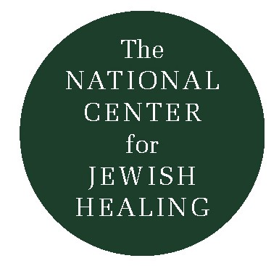
Walking: A Meditation

To prepare for this meditation try to re-experience feelings of physical strength and weakness in your body. In your mind liken the “journey of life” to a very long walk from infancy on. Sense the presence of God as you re-experience different stages, both of strength and weakness, in your life.

Imagine yourself as an infant, not quite ready to walk. You are in a place which feels very secure. See yourself trying to stand or to move in some tentative, exploratory way …You have no sense of yourself as a separate being, apart from what surrounds you…

You are walking-no boundaries between yourself and the environment around you. No boundaries, walking with God, blameless. This is your earliest memory, when you were like Noah: “blameless in his generation…Noah walked with God: Et ha Elohim hithalech Noah.” (Genesis 6:9)

Walking in wholeness, fully present, nothing separating you from anything. Walking with God…

As you picture yourself in your secure environment, notice a door in the distance. You feel compelled to go towards the door. “Lech lechah: Go forth.” Walk toward the door. With each step closer to the door, you sense your life-without boundaries fading.

As you touch the door handle, the feeling of fading boundaries is replaced with a growing sense of strength, sturdiness, independence. Open the door and step out. You walk forward in confidence and with a strong sense of self. You are no longer walking with God but walking before God. The memory of when you were like Abram: “Hithalech lefanai, veheyeh tamim: Walk before me and be blameless.” (Genesis 17:1)

Continue walking. You are walking along a path that seems to stretch forever into the distance. Walking…walking…walking…Many years of sturdy walking before God, trusting your body to take you through life in strength. Your eyes focused on the future – the memory, the turning back and looking back on the time of blameless wholeness with God has faded, is so vague.

You have been walking a long time now. Though your body continues to move forward, very gradually you are becoming weary, tired…no longer master of strength, sturdiness, optimism. Feel the weariness.

“What’s the point of this long journey?” you ask yourself. At times you feel resigned, other times angry. Lately, it’s protest. Why this body…only to betray me? A body I don’t recognize. Where can I be if I am not with God, nor am I with myself as I have known myself for so many years? “U-mah betzah ki shamarnu mishmarto v’chi halachnu k’doranit: What have we gained by keeping God’s charge, and walking in mourning, before the Lord of Hosts?” (Malachi 3:14)

So much darkness, the heaviness of mourning for what you have lost makes it harder to continue on. Each step slower now, and often painful as if you’re leaving behind the body you once knew and are entering a valley of darkness.

But strangely, you are not frightened; you are calm. You remember the purpose of your journey. The place from which you have come is the place to which you are going, a safe place. “Ki holech adam el olamo: For [we set out], we walked to [our] eternal abode.” (Ecclesiastes 12:5)

When the dust of this journey settles, you realize your lifebreath will return to God. “V’yashov he-afar al-ha’aretz keshe-hayah v’ha-ruach tashuv el-ha Elohim asher netara: And the dust returns to the ground as it was, and the lifebreath returns to God who bestowed it.” (Ecclesiastes 12:7)

Notice the calm stillness as you stop walking. Look around, see that though you are no longer walking, God is there with you, right behind you, as always. God has been as constant as your most constant companion. “Gam ki-elech b’gey tzalmavet lo-ira ra ki-atah imadi: Though I walk in the valley of the shadow of death, I fear no harm, for You are with me.” (Psalm 23-4)

You have been in God’s presence always. You do not have far to turn to return to the breath of all life. Return to God and God will return to you. “Shuvu elai v’ashuvah aleichem: Return to Me and I will return to you. Shuvu elai v’ashuvah aleichem.: (Malachi 3:7)

Rabbi Susan Freeman was the Education Director of Congregation B’nai Israel in Northampton, MA and a member of the Board of the Jewish Healing Center.

The Outstretched Arm
Vol. I, No. 1

Fall 1993

