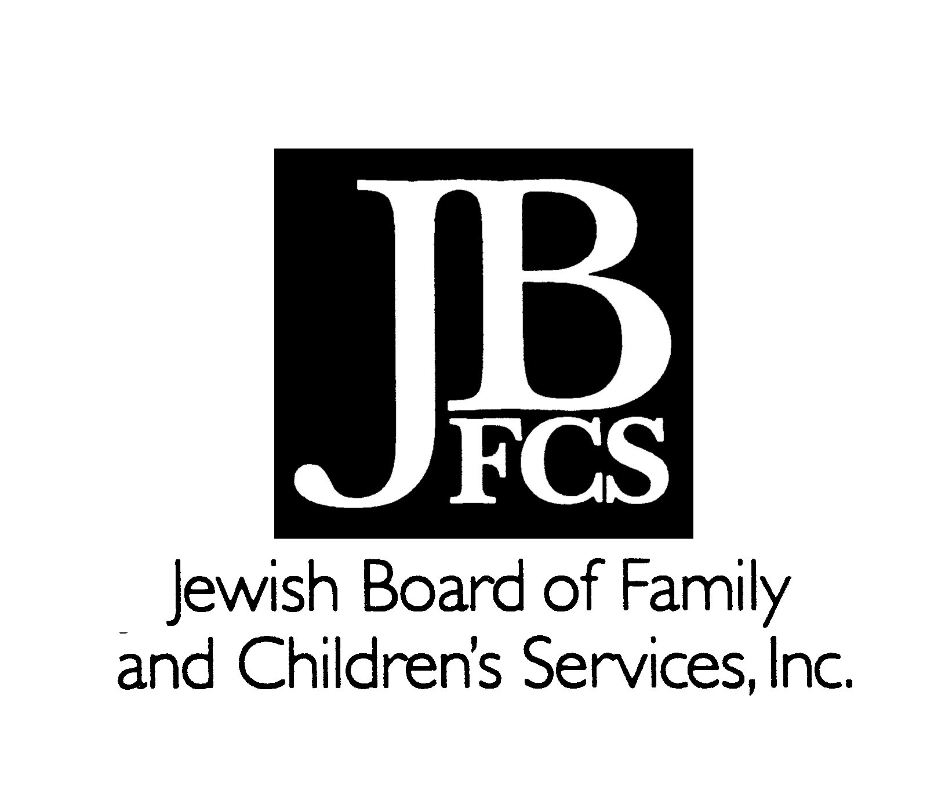
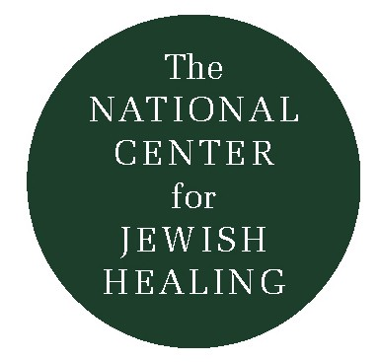
Praying for Those Who Heal,
For Those Who Care:

Two Mi Sheberakhs

One of the central Jewish prayers recited on behalf of those who are ill or recovering from illness or accidents is known as the Mi Sheberakh (the name is taken from the prayer’s first two words.) It asks for both physical cure and spiritual healing, seeking blessing, compassion, restoration and strength, within the community of others facing illness as well as all Jews, all human beings.

The Jewish tradition, of course, takes a systematic approach to healing-it is mindful of everyone who feels the impact of illness, pain, and loss, including but not limited to the individuals who are themselves suffering. Indeed, it understands that all those near and dear to the patient face their own set of challenges, at least on a spiritual level. It is important, then, that Jewish healing be multi-directional, and that our prayers not only be about those who are ill, but by them-so that they may express their love for and appreciation of those who are caring for them, in imitation of, and partnership with God’s healing and love.

Toward this end, we present to you two additional Mi Sheberakh prayers-one for people who are ill to say for their health care professionals and one to offer for family and friends (available on pocket-sized cards with Hebrew text). These two versions are suggestive – you may want to add to them or compose your own personal prayer, in your own words. But don’t hesitate to “take words with you, and respond to God…” (Hosea 14:3).

Rabbi Simkha Y. Weintraub, CSW
Rabbinic Director
Jewish Board of Family and Children's Services

Mi Sheberakh for Family Members or Close Friends
(to be recited by patient)

May the One who blessed our Matriarchs and Patriarchs
Sarah, Rebecca, Rachel, and Leah
Abraham, Isaac, and Jacob
bless and strengthen
my (family member, good friend, etc.)
May s/he be instilled with patience and fortitude,
sensitivity and understanding,
with courage and hope.

May others reach out to her/him
With tenderness and lovingkindness
and may s/he receive
the blessings offered
by our community and tradition.

Help her/him to know
How much I appreciate her/his love and devotion.

Give her/him a long, full, peaceful, and happy life
marked by a complete healing,
a healing of spirit, and a healing of body,
now and always,
and let us say,
Amen.

Mi Sheberakh for Health Care Professionals
(to be recited by patients)

May the One who blessed our Matriarchs and Patriarchs
Sarah, Rebecca, Rachel, and Leah
Abraham, Isaac, and Jacob
bless and strengthen
my (doctor/nurse/etc.)
and all who seek to heal those who are suffering.

Imbue her/him with courage, confidence,
understanding, and compassion
so s/he may join You
in the work of healing.

May s/he not surrender in despair,
uncertainty, or fatigue,
but engage in Your work
with wholeheartedness and devotion.
Help her/him to accompany me
throughout my journey-
to speak with me,
to listen to me,
to be with me
so that together we may strive
for a complete healing,
a healing of body and a healing of spirit,
soon, speedily, without delay,
and let us say,
Amen.

Outstretched Arm

Vol. 5 Issue 3

Fall ’96
