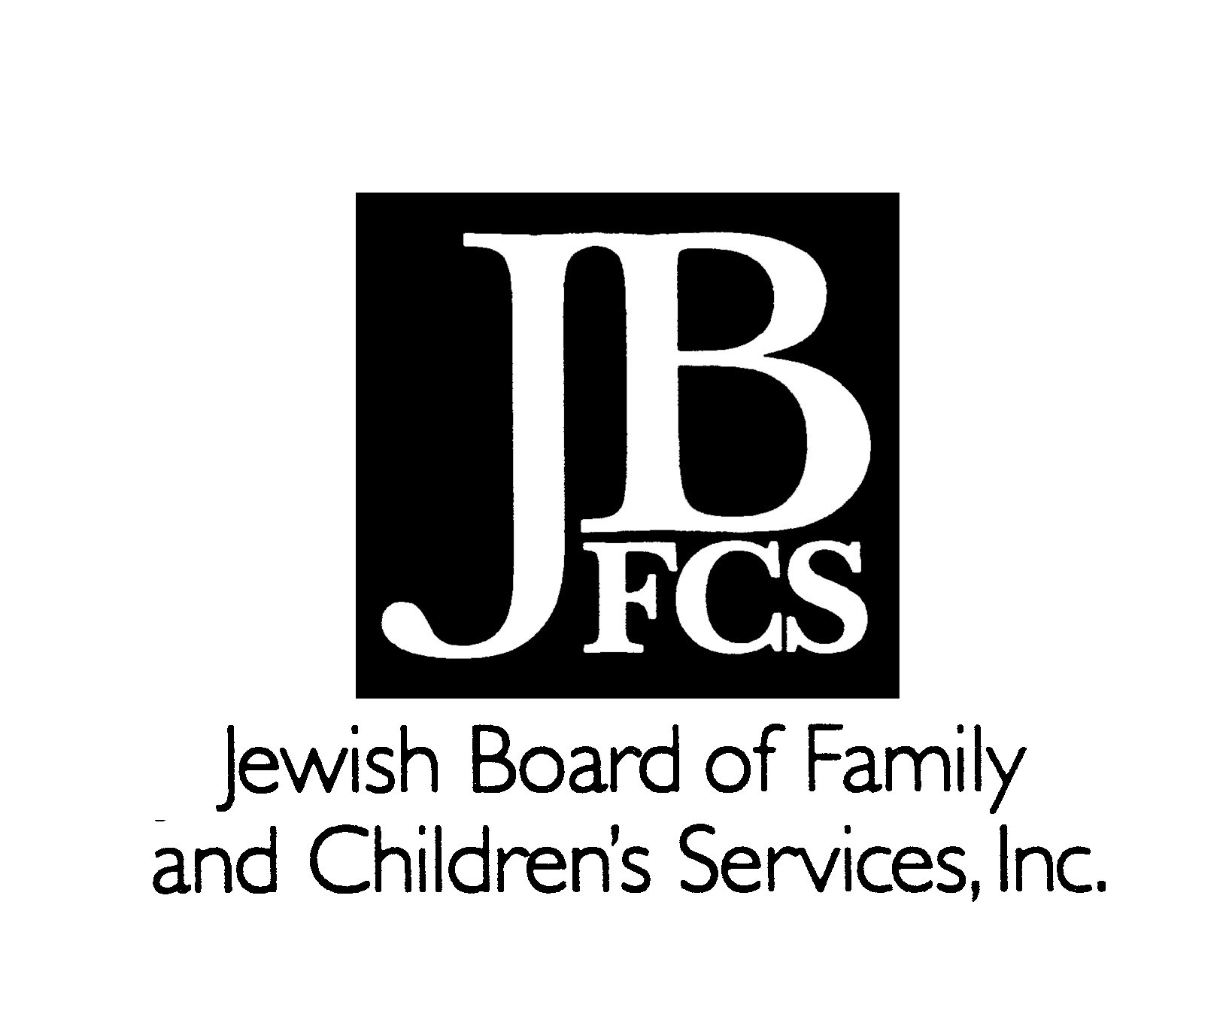
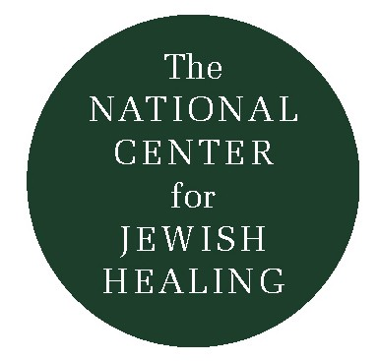
Rabbi Nancy Flam’s
Reflections Upon Psalm 150: Praise, Joy, Breath

The 18th century Hasidic master Reb Nachman of Breslov, the great-grandson of the Baal Shem Tov, taught that prayer is a powerful means of bringing about Tikkun Olam, Repair of the World: as a way of effecting union between human beings and God, between human beings with human beings, and between human beings with the universe. He identified ten psalms as having special power to bring a true and complete healing, R’fuat HaGuf (healing of body) and R’fuat HaNefesh (healing of spirit). Rabbi Nachman designated these ten psalms the Tikkun HaKlali, (the Complete Remedy); but he declared that each of us must find our own way into each psalm.

The following essay is excerpted from the book, Healing of Soul, Healing of Body, edited by Rabbi Simkha Y. Weintraub, CSW.

Praise
How can one praise God in the midst of serious illness? Praise God for one’s situation not being worse? What if it is nearly as bad as one can imagine? Praise God for the memory of health? What if one was born with congenital disease? Praise God for the depth of experience and insight which can come through suffering? Who wouldn’t trade a little insight for a modicum of relief?

The psalm says “Praise God’s mighty deeds; praise God according to God’s abundant greatness.” What are these mighty deeds, this abundant greatness? The poem is vague; I do not know the author’s intention. But I do know that what one considers God’s “greatness” will depend upon one’s understanding of God’s nature and ways: The mighty deeds might refer to God intervening in history: performing miracles such as splitting the Red Sea. Personally, I cannot conceive God this way: a power who willfully changes the laws of nature to help a particular people. But I do affirm and praise God as the One who makes miracles everyday, according to the laws of the physical universe and the human spirit: the awesome power we sense as we witness fall turn to winter, and winter to spring; the One we feel when we experience true love and compassion; who has willed the natural cycle of growth and decay; in whose presence we find company in prayer. Such greatness pertains whether I am ill or well. Praise of God is not about me or my condition; it is about the reality of God.

Joy
It may require a psycho-spiritual tour de force to praise God with joy and gladness in the midst of illness, but Rabbi Nachman challenges us to do so. Psalm 150 is nothing short of ecstatic, a glorious symphony which rises to a dazzling crescendo: shofar blasts, harp and lyre, timbrel, dance, lute and pipe, cymbals crashing loudly, furiously. Perhaps the music one makes is loud and furious to drown out one’s own complaint. Perhaps the wildness expresses something crazed. Or perhaps, in a rare moment of grace, one might play the music without fury, in touch with happiness, miraculously connected to God with praise in one’s heart, lamrot hakol: despite everything.

Breath
HallaluYah: Praise God! The most breathy name of God is used here: Yah. Praise the Creator who breathed the breath of life into Adam and Eve and each one of us.
“The rabbis of blessed memory said, ‘Let every soul (neshama) praise God.’ This means: Praise God with each and every breath (neshima), so you can say at every moment and continually, ‘Blessed is the Merciful One, Ruler of the Universe, Master of this moment.”
The last line in the final psalm of Rabbi Nachman’s Tikkun brings us to an awareness of the breath, rooting our being in the present moment, its reality and blessing. Fully present and mindful, we recognize that at all times, sick or well, we “have only moments to live.”

Psalm 150

Halleluyah/Praise God!
Praise God in God’s sanctuary;
Praise God
In the vast expanse of Heaven!
Praise God for mighty deeds;
Praise God
According to God’s abundant greatness!
Praise God
with the blowing of the shofar;
Praise God
with the lyre and the harp!
Praise God
with strings instruments and flute!
Praise God
with resounding cymbals
Praise God
with clanging cymbals!

Let every breath of life praise God.
Halleluyah/Praise God!

Rabbi Nancy Flam
Outstretched Arm, Volume 5, Issue 1
Fall 1995
