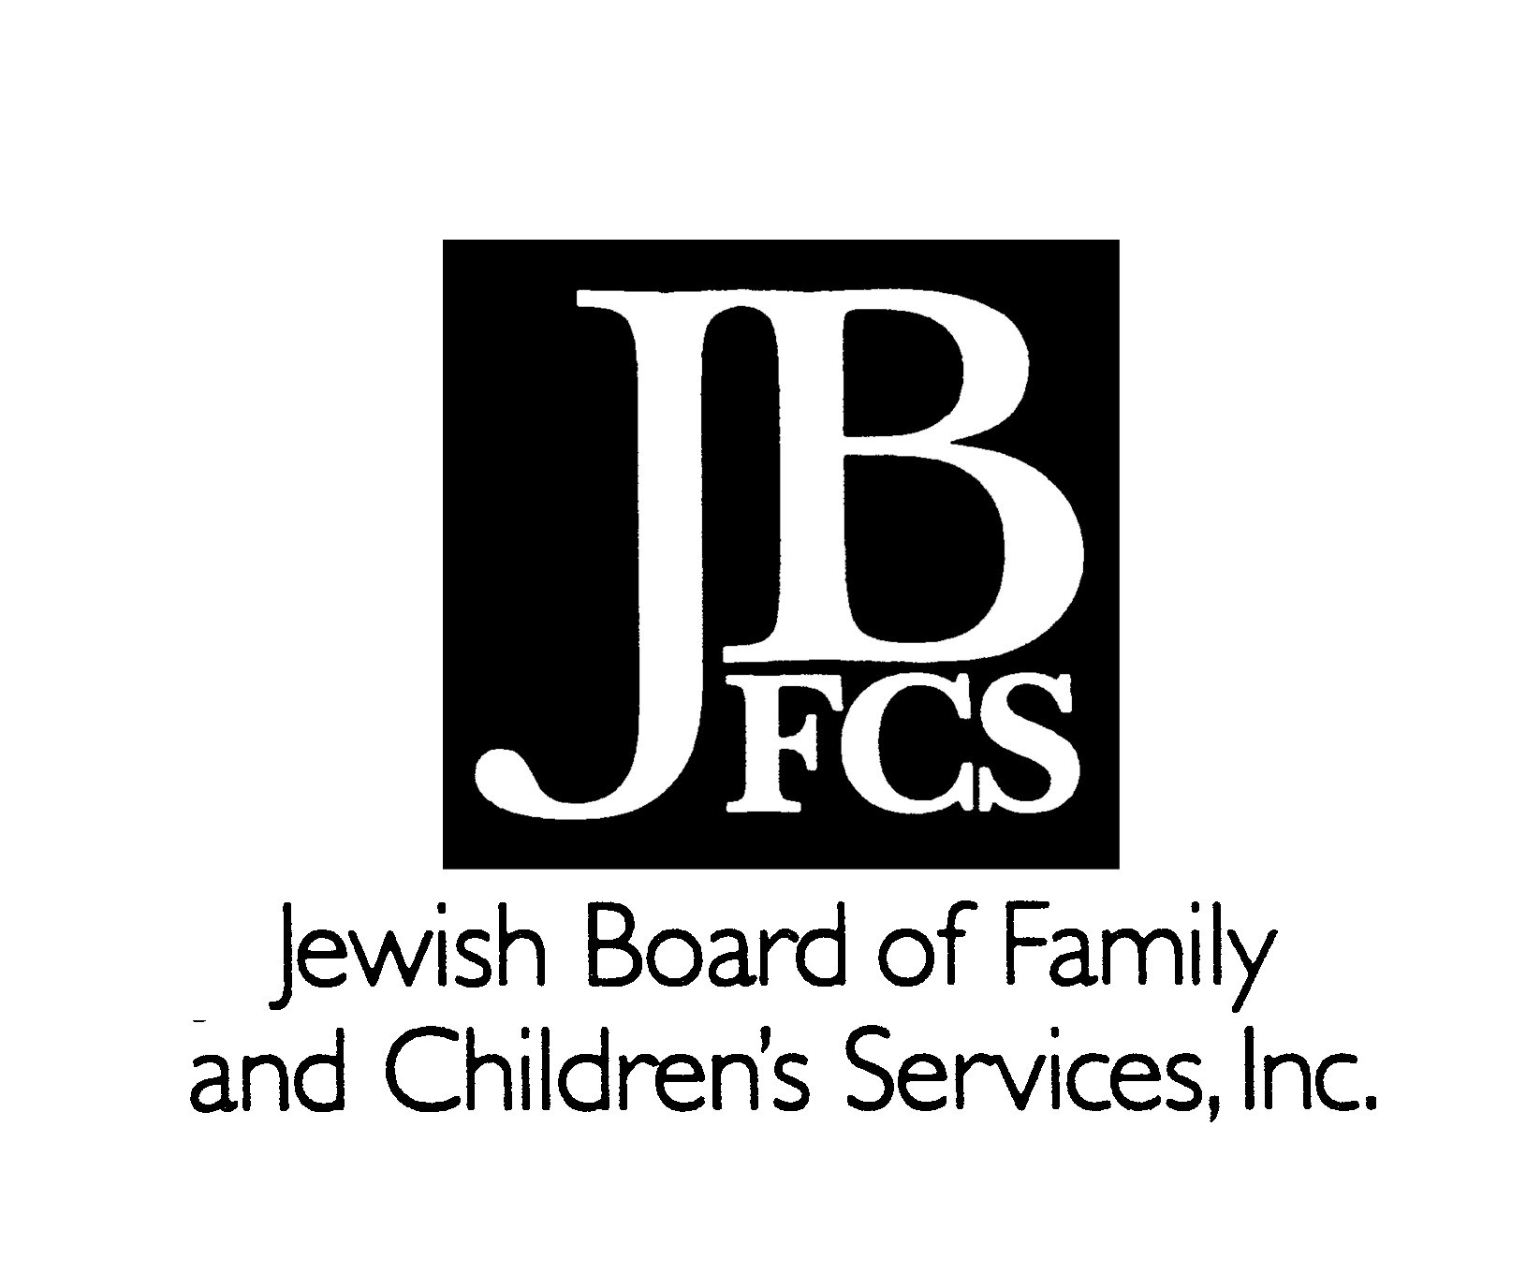
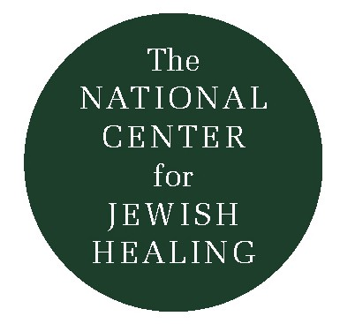
Finding Psalms
by Debbie Perlman

Rabbi Peter Knobel introduced the NCJH to the wonderful poetic/liturgical work of Debbie Perlman. We asked Debbie if she would permit us to share some of her work with you. What follows is a brief introduction in her own voice, plus a sampling of her psalms, written in 1996.

Debbie died inWinter, 2002 shortly after preparing another group of wonderful psalms for the NCJH on Caretaking. We pray that we may continue to amplify her voice and emulate her example of reaching out to others.

“I did not set out to write psalms. The first was written for a dear friend. About to undergo surgery, she was frightened by the loss of control. The second was my answer to a friend from years before, phoning, weeping her anguish of breast cancer recurrence, her desperate prognosis. After these first few psalms, the words began to be poured into me. They woke me up at night and sang in my dreams, sustaining me through a long dark winter and dismal never-did-arrive Chicago spring. I discovered that in a strange and unshakeable way, I had been called to write these words. The ancient rhythms that stirred King David were reverberating in me. Somehow, I belonged.

Probably, the most remarkable thing that has happened has been what my psalms have done for me. I have found the glass more often half full, often brimming, as I meet and speak with people who pray with my words and are moved by them. When I send a psalm out over e-mail, I am released from the disability that keeps me hooked to oxygen, walking slowly. My psalms remind me again and again of my survival, my tenacity, the blessings of good husband and family and friends. When I write, I let go of the anger and the fright, the anxiety for my daughter at a far away university, growing up, moving on. When I hear my words read in a communal worship, I am as transfixed as the first time I saw them on my computer screen. These words strengthen my faith in my ability to weave a lasting thread in the pattern of holiness, bound tightly to God’s design.”
Debbie Perlman z”l www.HealingPsalm.com

Psalms for a New Day: Tehillim shel Yom Chadash (Rad Publishers,
ISBN: 0-9644570-3-2: $10.00) is a collection of Debbie Perlman’s first 100 psalms. It is available from the publisher, 2849 Birchwood, Wilmette, Illinois 60091.
The Outstretched Arm, Vol. 5 Issue 3 Fall ’96

Nine
For final healing
(z”l: C.R.S.)

Like a pure crystalline tone,
Sounding in the deepest fear of night,
So will You call to me
To leave this land of my distress.

O let me turn to You;
Let me loose the steel bands of my
dread
And listen for the ringing
Of your summons.

How can I leave with so much
undone?
How can I move away from this place,
And follow, fearless, into the strength
Of Your concern for me?

I am only Your creation.
Striving to create my own
Remembrance,
To leave this work with knowledge
Of my passage through it.

So soon You call me to Your harmonies:
To close my manuscript,
To sing unaccompanied
These notes of my life, the final hymns.

Still my terror with clear notes,
Righteous One.
Quiet me with a silken melody;
That in accepting Your judgement,
I might turn to sing with You.

Copyright 1995
by Deborah M. Perlman z”l

121

One Hundred Twenty-One

To survive the high noon of diagnosis,
We found optimistic eyeshades,
Holy One,
Blinders of hope for years to come,
Setting our love fast with Your love.

To survive illness’ overcast glare,
We pulled out woven hats, Holy One,
Our community of treatments
And duties,
A dailiness of life as it was.

To survive the wornaway of days,
The nights,
We wrapped ourselves in hooded
Robes,
Waking in dark hours, Holy One,
Praying near dawn for healing,
dreamless sleep.

To survive these ending days,
You draw taut the sheet of courage,
Holy One,
Binding us up in spent
anger transformed,
In enduring love.

To survive alone,
You draw me to You, Holy One,
Remembering joys of unshaded
brightness,
Hatless, uncovered, unscathed.

Copyright 1995, 1998
by Deborah M. Perlman z”l
