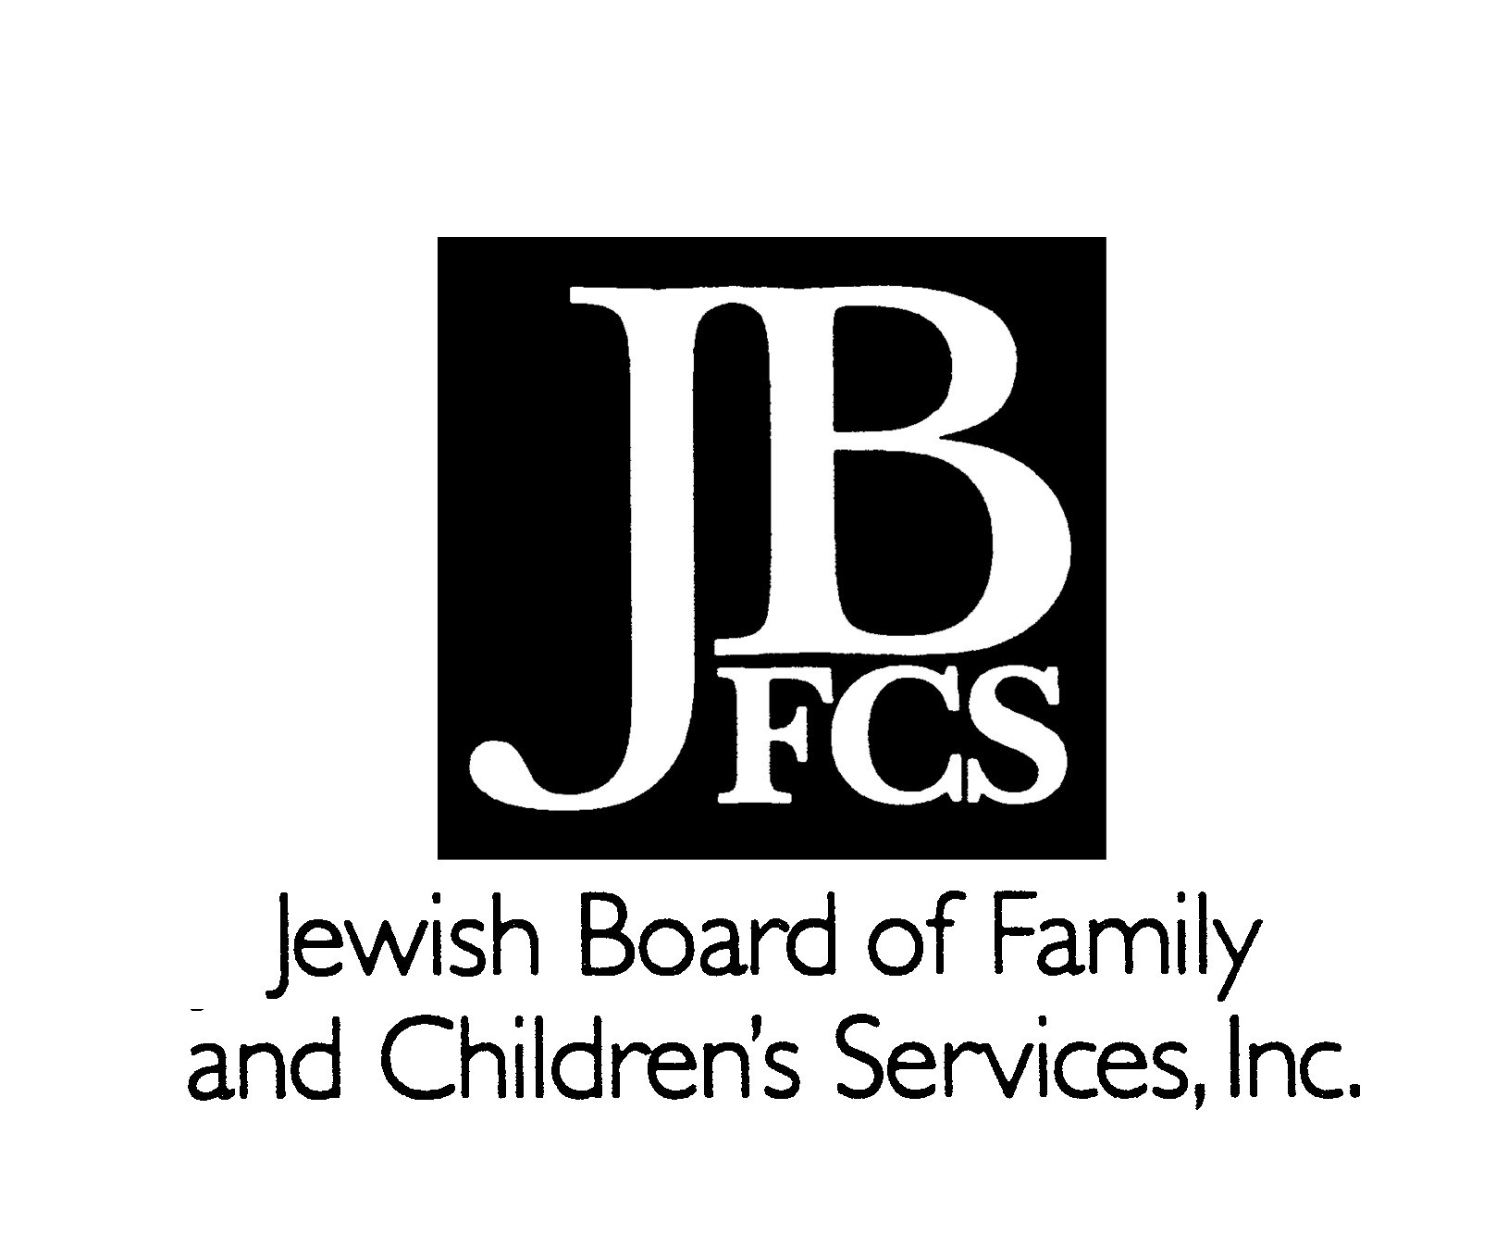

Ten Quotes from Pirke Avot*

Simon the Just…used to say,
“Upon three things the world stands:
On Torah, on (Divine) Service, and on Deeds of Lovingkindness.”

Pirke Avot 1:2

Hillel used to say:
”If I am not for myself, who will be for me?
And if I am only for myself, what am I?
And if not now, when?”
Pirke Avot 1:14

Simeon, the son of Rabban Gamliel, said:
“I was brought up all my life among the Sages,
and I have found nothing as good for the body as silence,
and it is not the study/explication that is the essence – but the practice/doing,
and whoever is profuse of words occasions sin.”

Pirke Avot 1:17

Rabban Simeon, son of Gamliel, said,
“On three things the world stands: On Judgment, on Truth, and on Peace…”

Pirke Avot 1:18

Rabbi Yose said:
”Let your friend’s property be as precious to you as your own;
Give yourself to studying the Torah, for it does not come to you by inheritance;
and let all your deeds be done in the name of Heaven.”

Pirke Avot 2:12

He (Rabbi Tarfon) also used to say,
“It is not your obligation to complete the task,
but neither are you at liberty to desist from it entirely…”

Pirke Avot 2:16

Another teaching of Rabbi Akiva:
“Everything is foreseen, yet free will is granted;
By goodness is the universe judged,
yet all depends on the preponderance of (good) deeds….”

Pirke Avot 3:1

Ben Zoma said,
“Who is wise? The one who learns from all people…
“Who is mighty? The one who subdues the evil inclination…
“Who is rich? The who who rejoices in his portion….
“Who is honored? The one who honors other human beings….”

Pirke Avot 4:1

Rabbi Jacob used to say,
“Better is one hour of t’shuvah (returning/repentance) and good deeds in this world
than the whole life of the world-to-come
and better is one hour of spiritual bliss in the world-to-come
than all the the life of this world!”

Pirke Avot 4:17

Rabbi (Meir) said,
”Look not at the flask but at what is therein;
There may be a new flask full of old wine,
And an old flask wherein is not even new wine.”

Pirke Avot 4:20

* Pirke Avot, lit. “Chapters/Ethics of the Fathers,” is the only nonlegal tractate of the Mishnah, included toward the end of Nezikin, the fourth of the six “orders” of the Mishnah (which is the codification of the Oral Law, based on biblical passages, recorded by Rabbi Judah HaNassi in 200 BCE, the end of 400-600 years of exegesis and teaching.). Pirke Avot is a brief, very accessible book, comprised, itself, of six chapters filled with the practical insights, moral advice, and spiritual sayings of ancient sages.

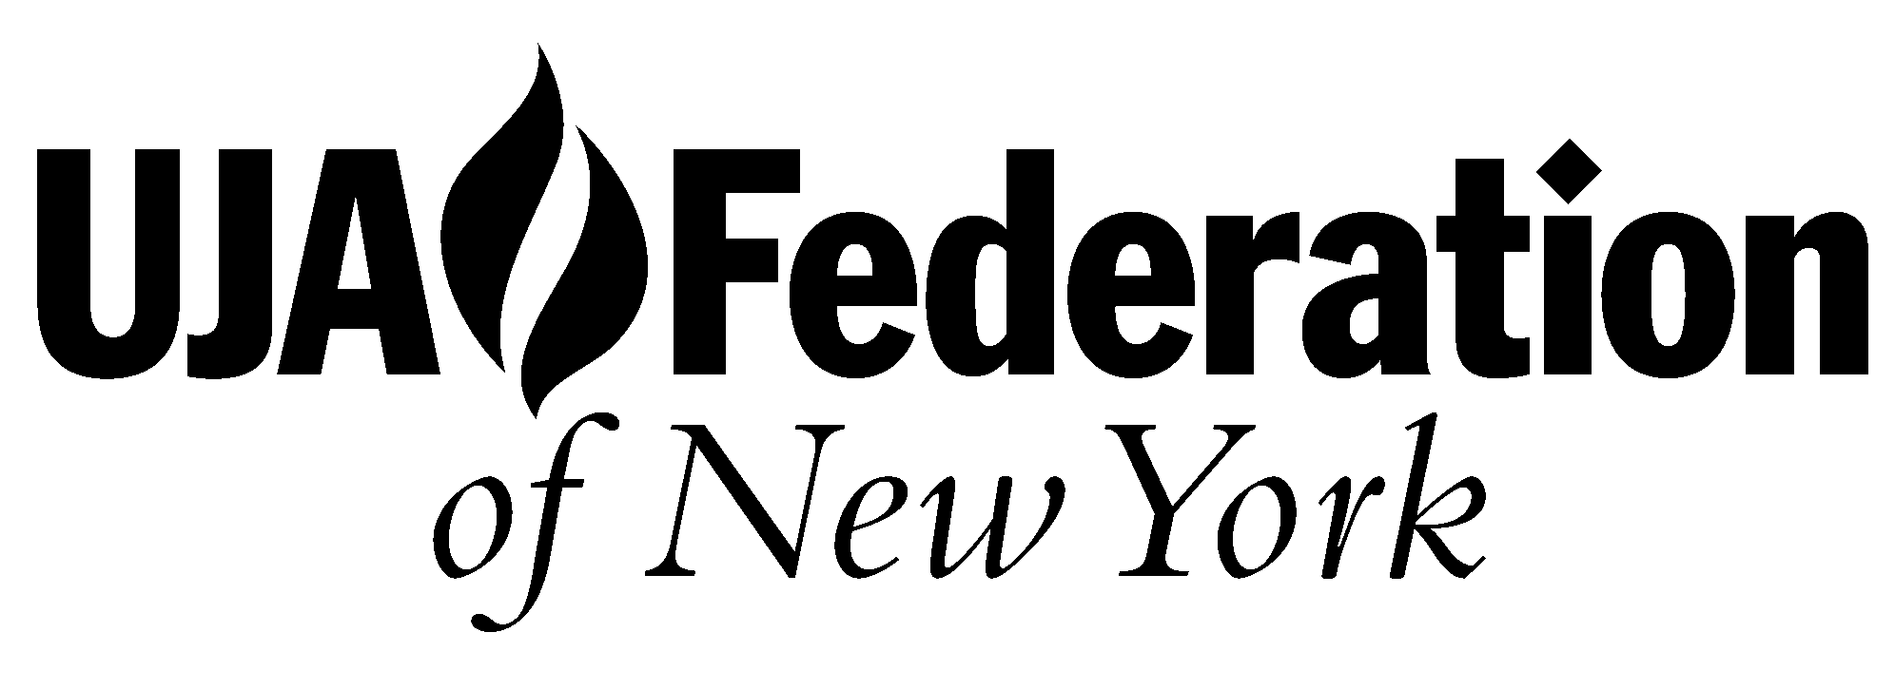
Selected, translated, and arranged by Rabbi Simkha Y. Weintraub, CSW © 2002

