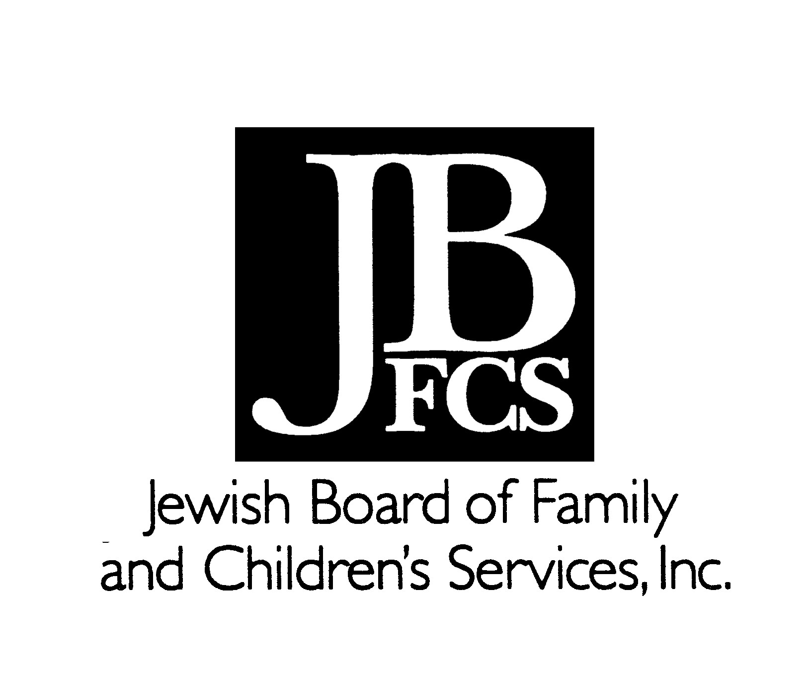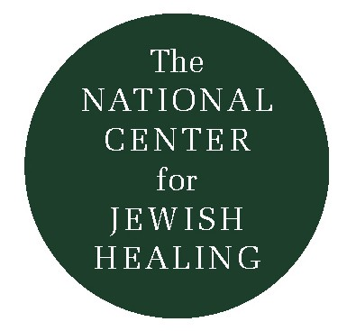

The National Center for Jewish Healing
and
The New York Jewish Healing Center

(c) Rabbi Simkha Y. Weintraub, CSW, 1997

“He who stands on a normal rung weeps;
he who stands higher is silent;
but he who stands on the topmost rung
converts his sorrow into song.”
Abraham Joshua Heschel, A Passion for Truth, page 283;
quoting a Hassidic teaching about mourning and loss.

L'Hayyim/For Life: Eighteen Songs of Healing

1. Lo i-ra mei-ri-v'voht ahm
a-sherr sa-viv, sa-viv,
sha-tu a-lai.
Ku-ma, HaShem, ho-shi-ei-ni!
I do not fear the thousands of people
that have set upon me, all around.
Rise up, Adonai! Save me, my God!
(Psalm 3: 7-8)
* * *
2. Va-a-nah-nu lo nei-da mah na-a-seh
ki a-leh-kha ei-nei-nu.
Z'khor ra-ha-meh-kha, A-doh-nai,
va-ha-sa-deh-kha,
ki mei-oh-lahm hei-mah.
We know not what to do --
Our eyes are upon You.
Remember Your mercy, Adonai,
and Your hessed/lovingkindness,
for they are eternal.
(II Chronicles 20:12; Psalm 25:6)
* * *
3. A-hat sha-al-ti, mei-et A-doh-nai,
O-tah a-va-kesh:
Shiv-ti b'vet A-doh-nai
Kol y'may ha-yai,
La-ha-zot b'no-am, b'no-am A-doh-nai,
U-l'va-kerr b'hei-kha-lo.
One thing I ask of Adonai,
One thing I seek:
To dwell in the House of Adonai
All my days,
To behold Adonai's pleasantness
and to meditate (experience/visit/hang out) in Adonai's
Sanctuary.
(Psalms 27:4)
* * *
4. Ka-vei el A-doh-nai
Ha-zak v'ya-a-metz li-beh-kha
V'ka-vei el A-doh-nai.
Have hope (trust) in Adonai
Be strong and your heart will be strengthened
Have hope (trust) in Adonai. (Psalms 27:14)
* * *

5. Ey-leh-ka, Ha-shem, ek-ra,
v'el A-doh-nai et-ha-nahn:
Sh'ma Ha-shem, v'ha-ney-nee,
Ha-shem, heh-yey oh-zer lee.
To you, God, I call,
and to Adonai I appeal:
Hear, God, and have compassion on me,
God -- be my Help. (Psalms 30:9,11)
* * *
6. Lev ta-hor b'ra-li, Eh-lo-him;
V'ru-ah na-khon ha-desh b'kir-bi:
Ahl tash-li-khei-ni mil-fah-neh-kha,
V'ru-ah kod-sh'kha ahl ti-kah mi-meh-ni.
Create for me a pure heart, God;
And the right spirit renew within me.
Don't cast me away from Your Presence,
Don't take Your Holy Spirit away from me.
(Psalms 51:12-13)
* * *
7. Va-ah-ni t'fi-la-ti, l'kha, A-doh-nai
Et ratzon,
Eh-lo-him, b'rov has-deh-kha,
A-nei-ni, b'eh-met yish-eh-kha.
May my prayer to you, Adonai,
be at a favourable time;
God, in your abundant kindness,
Answer me, with the truth of your deliverance.
(Psalms 69:14)
* * *
8. Im a-mar-ti ma-tah rahg-li
Has-d'kha Ha-shem yis-a-dei-ni.
Whenever I have said, "My foot has slipped,"
Your kindness/loyalty, Adonai, has supported me.
(Psalms 94:18)
* * *
9. Min ha-mei-tsar ka-ra-ti Yah
A-na-ni va-mer-hav Yah.
Out of narrow straits (distress) I've called out to God,
God answered me with wide open spaces (by setting me free).
(Psalms 118:5)
* * *
10. Pit-hu li sha-a-rei tzeh-dek
A-vo vahm
O-deh Yah.
Zeh ha-sha-ar lA-doh-nai
Tza-di-kim ya-vo-oo vo.
Open for me the gates of righteousness;
I will enter them
I will give thanks to God.
This gate is Adonai's,
The righteous enter it. (Psalms 118:19-20)
* * *

11. Eh-sa ei-nai el heh-ha-rim
Mei-ah-yin ya-vo ez-ri.
Ez-ri mei-im Hashem
O-seh sha-ma-yim va-a-retz.
I lift up my eyes to the mountains:
Where will my help come from?
My help comes from Adonai,
Creator of heaven and earth. (Psalms 121:1-2)

* * *
12. Hi-nei lo ya-num
v'lo yi-shahn
Sho-mehr Yis-ra-el.
Behold, the Guardian of Israel
neither slumbers nor sleeps. (Psalms 121:4)

* * *
13. Kol ha-oh-lahm ku-lo geh-sher tzar m'od
V'ha i-kar lo l'fa-hed k'lal.
The entire world is a very narrow bridge
And the essential thing is not to fear.
(Reb Nahman of Bratslav, Likutei Moharan 2:28)

* * *
14. Al ti-ra mi-pa-had pit-om
U-mi-sho-at r'sha-im ki ta-vo.
U-tzu ei-tza v'tu-far
Dahb-ru da-var v'lo ya-kum
Ki i-ma-nu El.
Don't be afraid of sudden terror,
Nor of the calamity that comes to the wicked.
"Devise your evil plots -- they will fail!
Lay out your wicked plans -- they are doomed!
God is with us!" (Liturgy)

* * *
15. Ra-bot ma-ha-sha-vot, b'lev ish,
Va-a-tzat Hashem hi ta-kum.
A-tzat Hashem l'o-lahm ta-a-mod
Mah-sh'vot li-bo l'dor va-dor.
Many are the ideas in a person's heart,
But God's design/purpose/plan is what stands.
God's design/purpose/plan stands forever,
God's ideas span from generation to generation.
(Liturgy)

* * *

16. Ha-shi-vei-nu, A-doh-nai, ei-leh-kha, v'na-shu-va
Ha-desh ya-mei-nu k'keh-dem.
Turn us, Adonai, back to you, and we will return,
Renew our days as of old.
(Lamentations/Eikha 5:21)

* * *
17. Sh'ma Yisra-el, A-doh-nai, eh-lo-heh-nu,
A-doh-nai e-had,
Hu eh-lo-heh-nu, Hu a-vi-nu,
Hu mal-keh-nu, Hu mo-shi-eh-nu.
V'hu yahsh-mi-eh-nu, b'rah-ha-mav sheh-nit,
sheh-nit l'ei-nei kol hai.
Hear, Israel, Adonai, our God, is One --
-- our God, our Parent, our Ruler, our Deliverer.
In mercy, God will respond to us
in the presence of all living beings.
(Deuteronomy 6:4; Shabbat Musaf liturgy)

* * *
18. Ha-n'sha-mah lakh, v'ha-guf pa-a-lakh,
Hu-sa na ahl a-ma-lakh.

The Soul is Yours,
The Body is Your creation --
Have compassion on Your handiwork!

(Selihot Liturgy)

(Also, check out Psalm 150!)

Al ti-ra mi-pa-had pit-om
U-mi-sho-at r'sha-im ki ta-vo.
"U-tzu ei-tza v'tu-far
Dahb-ru da-var v'lo ya-kum
Ki i-ma-nu El."

V'ad zik-nah, A-ni Hu;
V'ad sei-vah, A-ni ess-bol!
A-ni a-si-ti, va-a-ni eh-sa,
Va-a-ni ess-bol va-a-ma-leit!

Don't be afraid of sudden terror,
Nor of the calamity that comes to the wicked.
"Devise your evil plots -- they will fail!
Lay out your wicked plans -- they are doomed!
God is with us!"

Even to your old age, I am the same;
When you are grey-headed, still I will sustain you!
I have made you, and I will bear you;
I will sustain you and I will save you!

(Proverbs 3:25; Isaiah 8:10, 46:4))

